We are what we eat

Class Survey

Do the Eating Test individually and then compare your results with the rest of the group. Study and discuss the results with your partners.

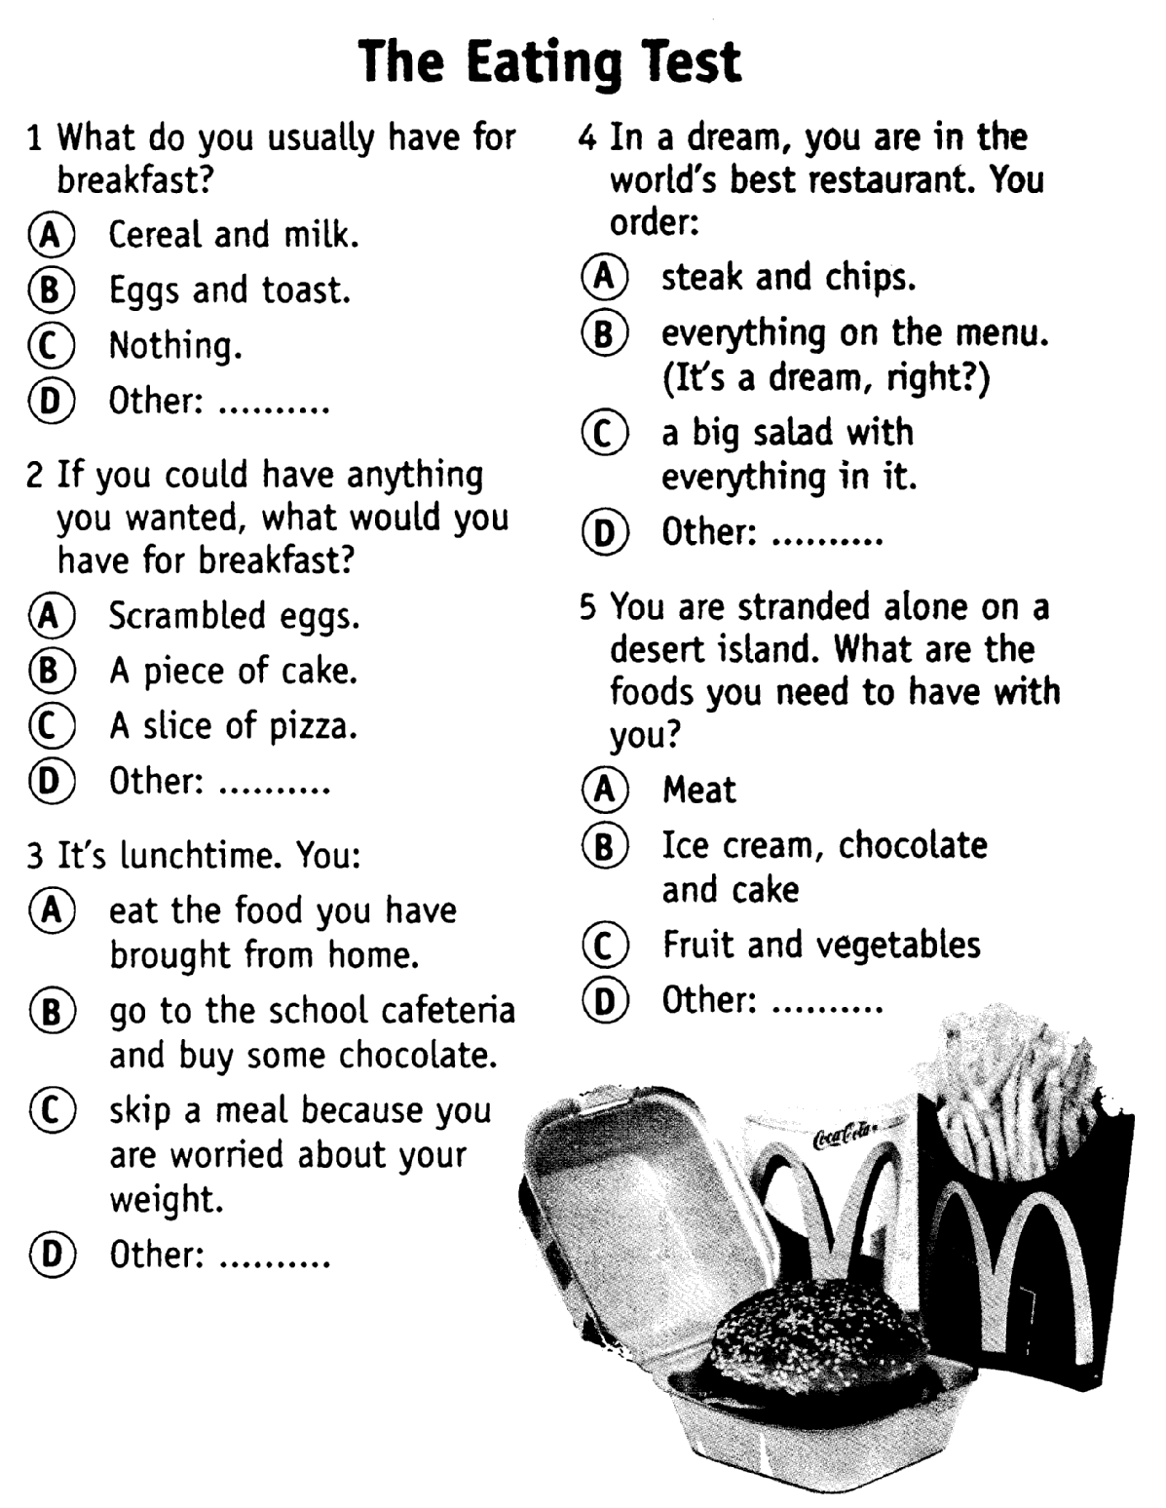
What are fattening rooms?
Listening. Questions to the text:

- Where do women mostly want to be slim?
- What does it mean “to be slim” in those places?
- Where do women prefer to be slim?
- What does it mean “to be fat” in those places?

- What are the negative attributes of a slim woman?
- How do people help girls to be fat?
- What do girls do in fattening rooms?
- What kind of food do girls eat in fattening rooms?

- Who serves food in fattening rooms?
- Why do girls grow fat in fattening rooms?
- Who visits girls in fattening rooms?
- When do Nigerian girls go to fattening rooms?

- Can a girl go to a fattening room after marriage?
- Why does a man want his wife to be fat?
- What might happen if parents do not send their daughters to fattening rooms?
- How long did the girls use to stay in fattening rooms in the old days?

- How long do the girls stay in fattening rooms now?
- Are fattening rooms popular in the cities? Why or why not?
- Where do people have a contest for the heaviest woman?
- What is the prize for the fattest woman?

Are you careful about WHAT you eat and HOW you eat???

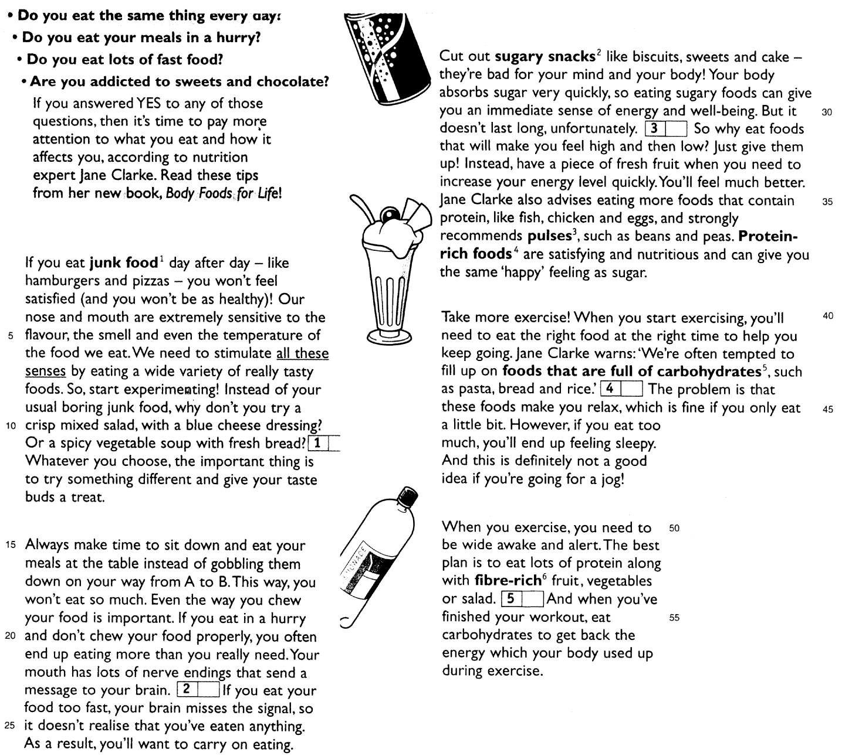

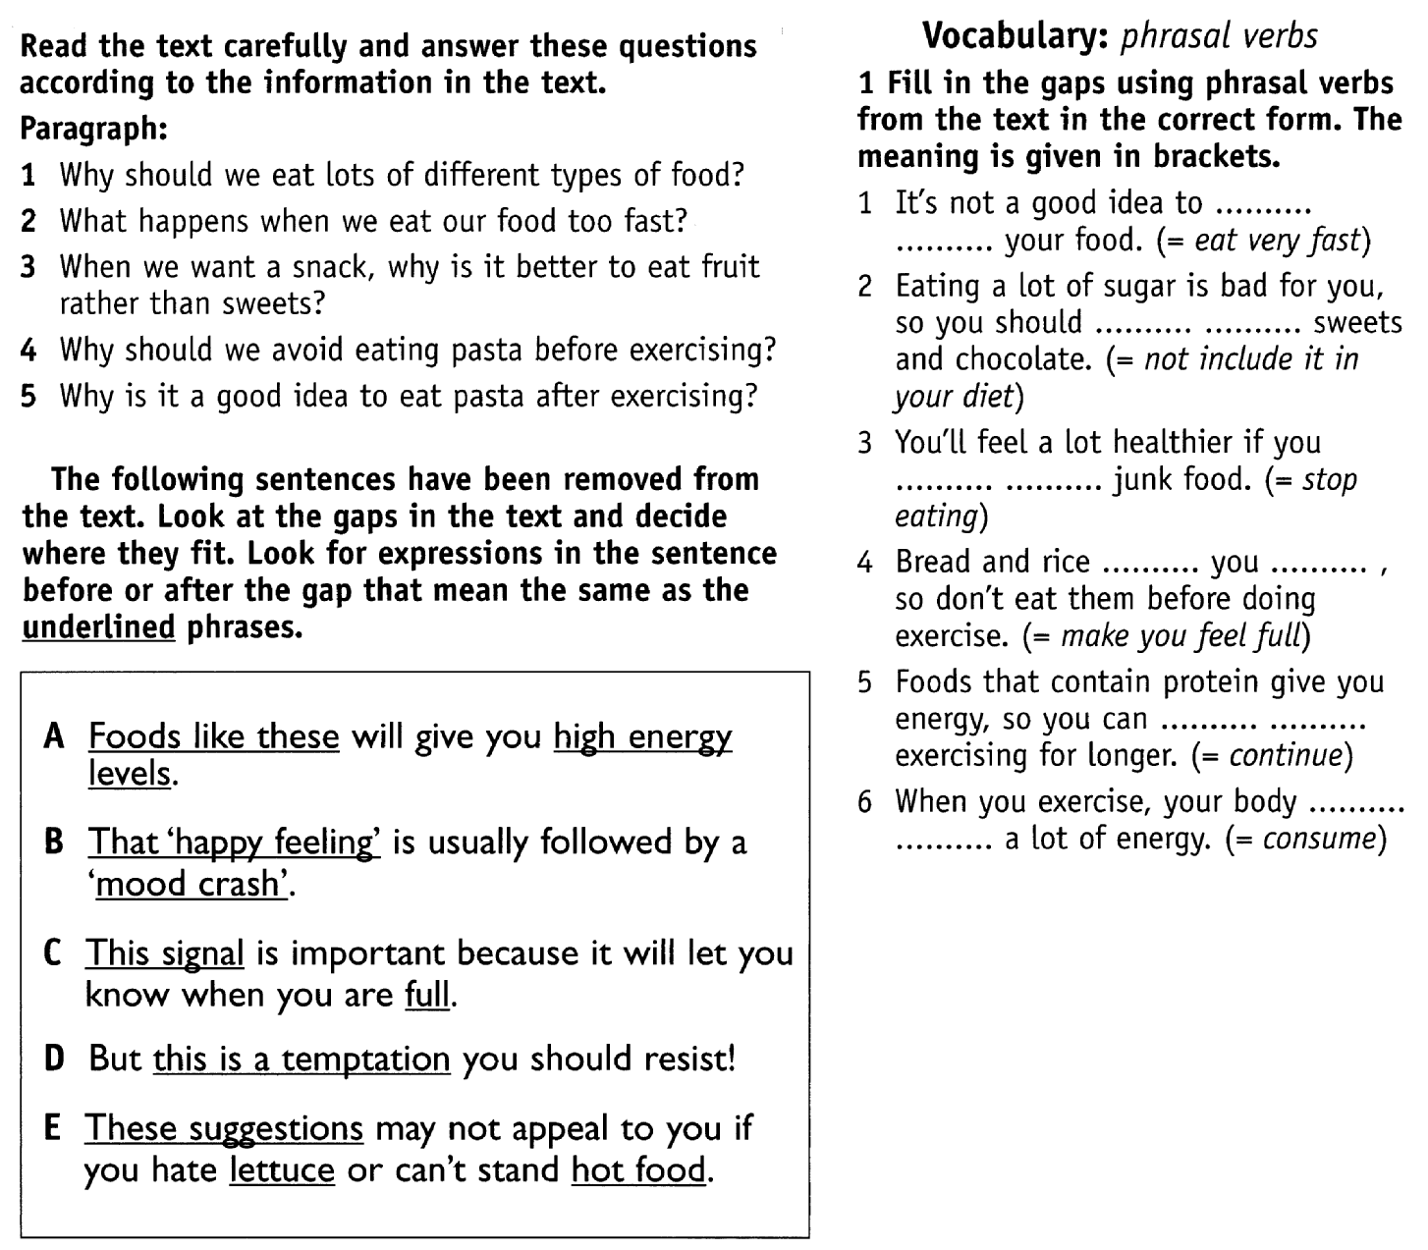

Grammar Block

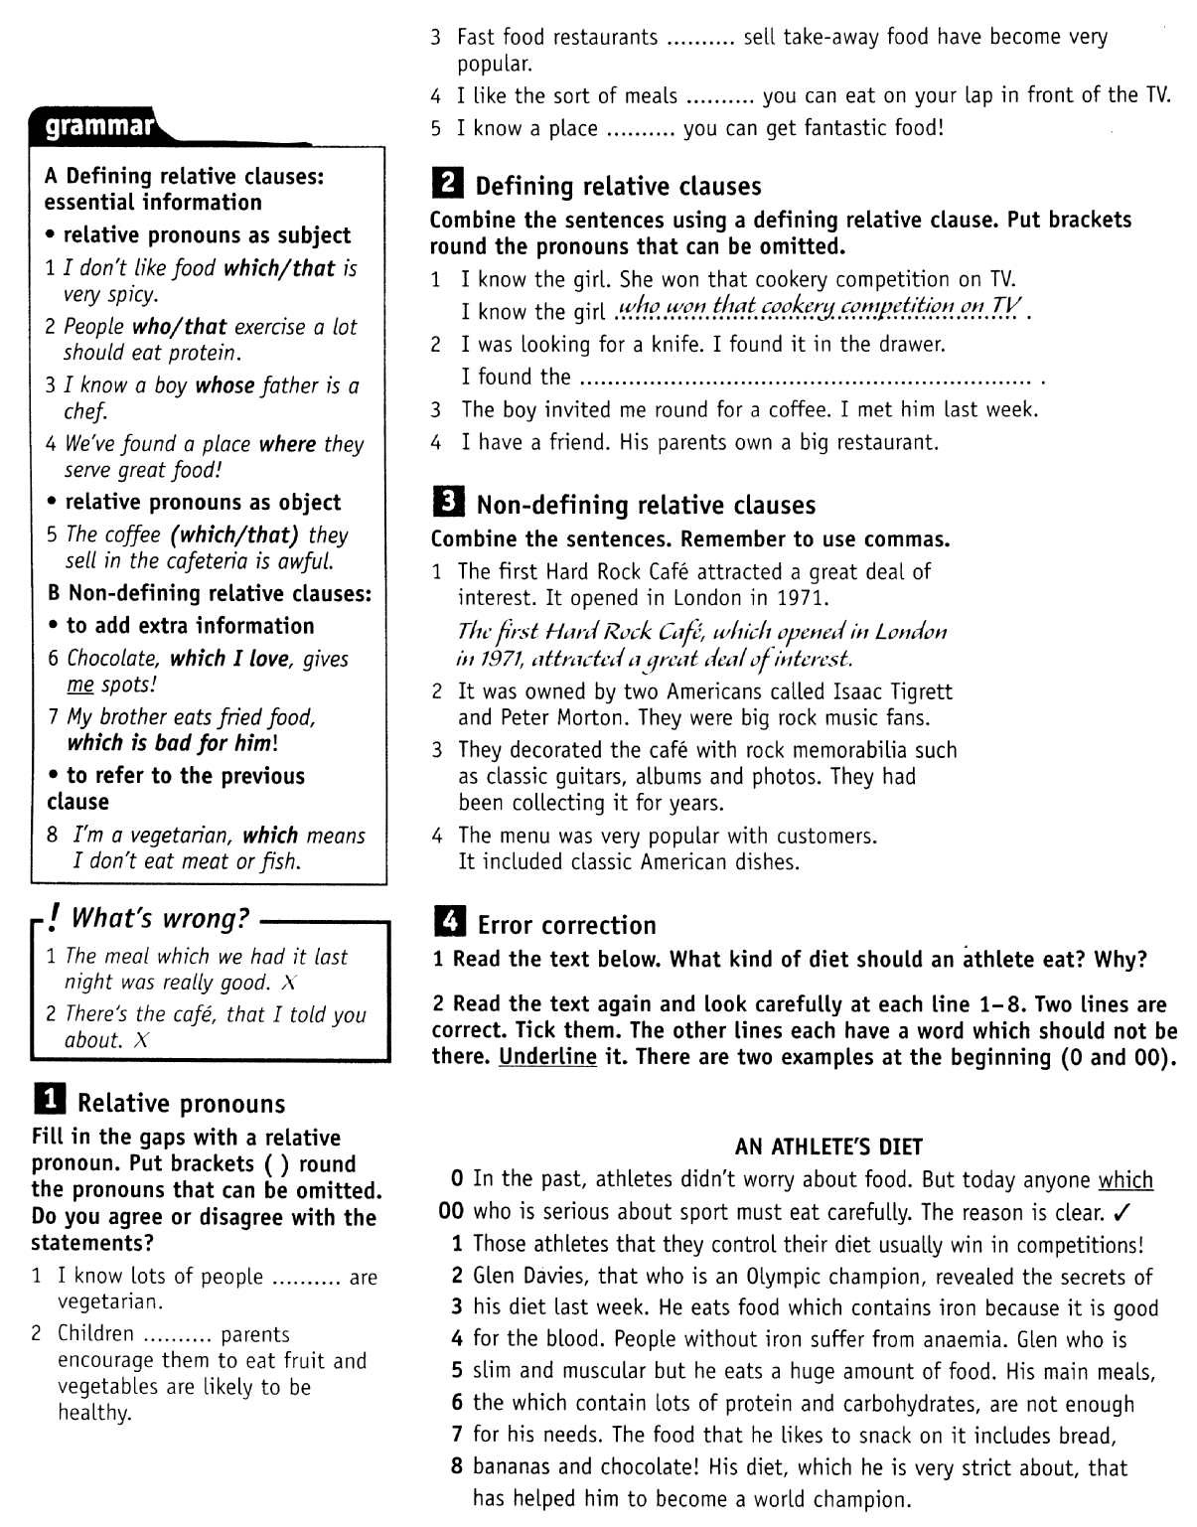

Vocabulary Block

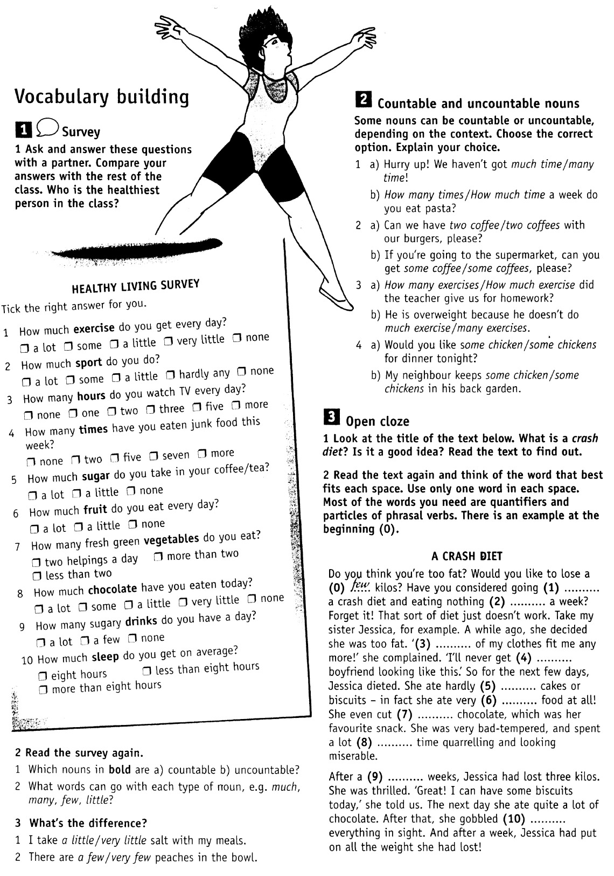

Song:

Honey Honey

ABBA
Honey honey, how you _________ me, ah – hah, honey honey
Honey honey, nearly _________ me, ah – hah, honey honey
I'd heard about you _________
I _________ to know some _________
And _________ I know what they mean, you're a love …
Oh, you make me _________
Honey honey, let me _________ it, ah – hah, honey honey
Honey honey, _________ conceal it, ah – hah, honey honey
The way that you kiss _________
(The way that you kiss me _________)
The way that you _________ me tight
(The way that you're _________ me tight)
I feel like I wanna _________ when you _________ your thing
I don't wanna _________ you, _________, I don't wanna _________ you _________
So stay on the _________, girl, you ________ not get too _________
But I'm _________ stick to you, _________, _________ you'll never get rid of _________
There's no other _________ in this world where I rather would _________
Honey honey, _________ me, baby, ah - hah, honey honey
Honey honey, _________ me, baby, ah - hah, honey honey
You look like a _________
(You look like a _________ _________)
But I _________ just who you _________
(I _________ just who you _________)
And, honey, to say the _________, you're a _________ – gone beast!
So stay on the _________, girl, you _________ not get too _________
There's no other _________ in this world where I rather would _________
Honey honey, how you _________ me, ah – hah, honey honey
Honey honey, nearly _________ me, ah – hah, honey honey
I'd heard about you _________
I _________ to know some _________
And _________ I know what they mean, you're a love …
Oh, you make me _________

By Alyona Pavlova,
Moscow State University of Printing Arts

